**User Story:**

1. As a customer, I want to be able to see the past orders, so that I can review my past orders.
2. As a customer, I want to be able to have the orders that I order the most be at the top so that, I can easily select the most recommended ones.
3. As a customer, I want to be able to select the restaurants, so that my recommendations and menu are limited to one selected restaurant.
4. As a customer, I want to be able to rate my orders, so that I can be recommend similar dishes.

**Schedule:**

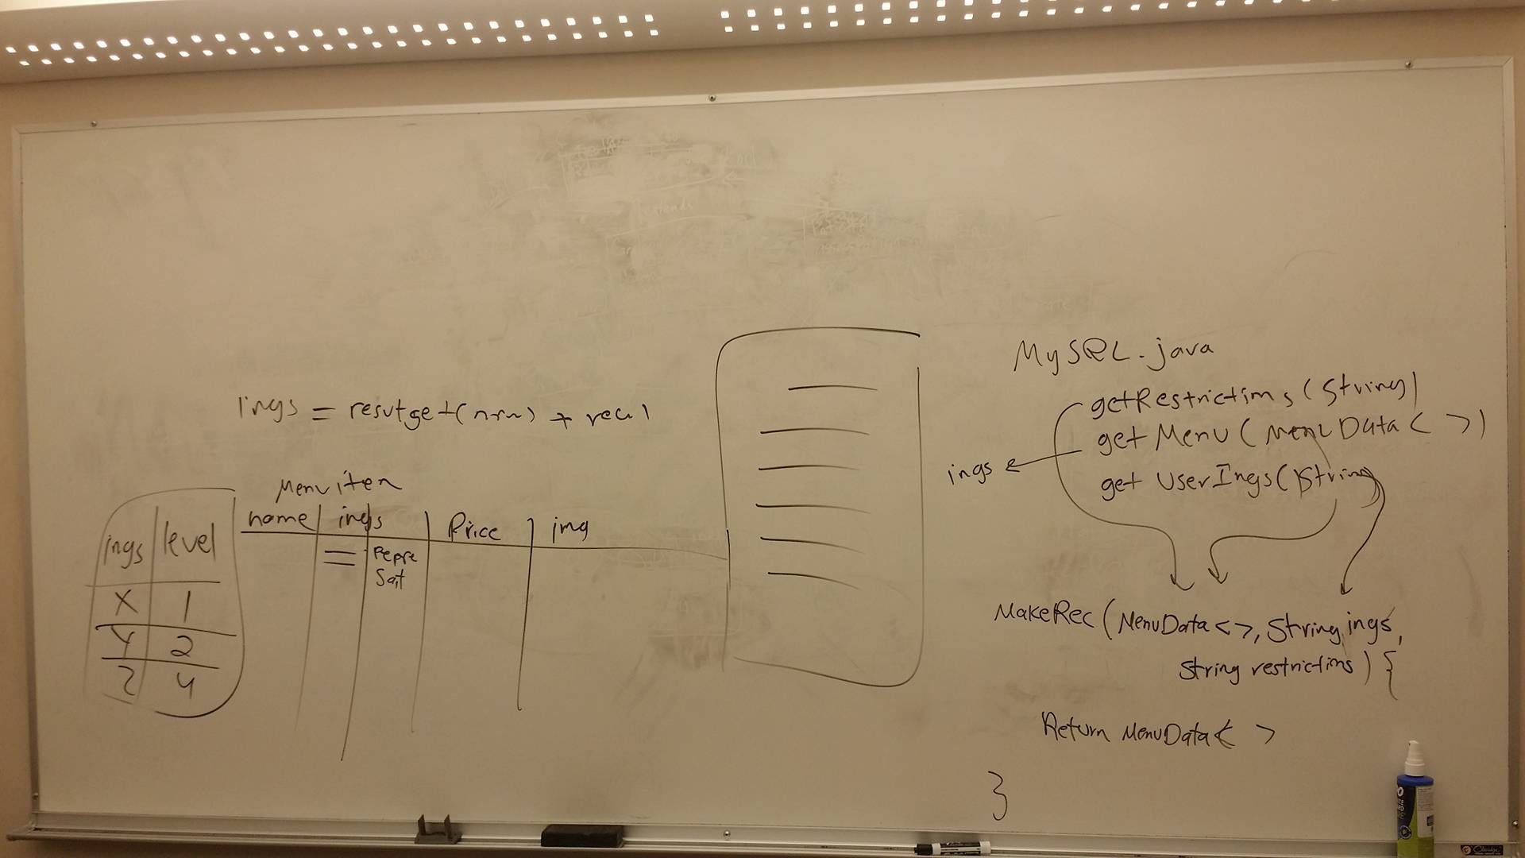

1. finish functionality for recommendation
2. sort recommendation
3. getRestrictions()
4. getMenu()
5. get UserIng()
6. Finish functionality for putting in orders and updating database
7. Add employee mode for app that shows orders
8. Make past orders visible